# OOP – Multimedia Shop

The goal of this lab is to practice **Object-oriented programming** by building a Multimedia Shop System for managing different items – movies, books and games. The items can be **sold** or **rented**.

## The Items in Our Shop

#### Step 1 – The Items

It's time to create the actual items in our shop.

* Book – holds **Author,** should be a non-empty string, at least 3 symbols long
* Game – holds **AgeRestriction** (either Minor, Teen or Adult)
* Video – holds **Length** (in minutes)

**Book**, **Game** and **Video** are all **Items** – therefore they should inherit the behavior of the **Item** class.

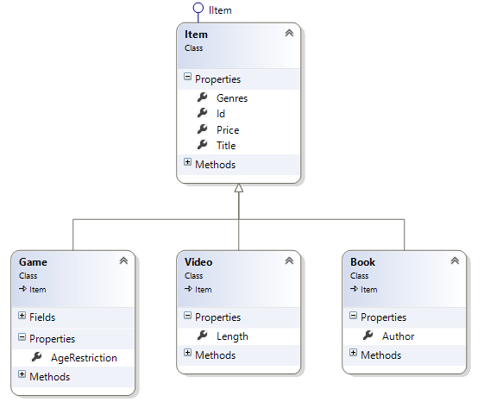

#### Step 2 – Class Constructors

Create the following constructors for each class:

* Item(id, title, price, genres)
* Item(id, title, price)
* Book(id, title, price, author, genres)
* Book(id, title, price, author, genre)
* Video(id, title, price, length, genres)
* Video(id, name, price, length, genre)
* Game(id, title, price, genres, ageRestriction) – age restriction is optional with default value **Minor**
* Game(id, name, price, genre, ageRestriction) – age restriction is optional with default value **Minor**

**Note:** genres is a **set of genres**, whereas genre is a single **genre** (represented as string).

Make sure you do NOT repeat any code by properly **reusing constructors** from the base class.

#### Step 3 – Test Your Classes

|  |
| --- |
| Item sallingerBook = new Book("4adwlj4", "Catcher in the Rye", 20.00m, "J. D. Salinger", "fiction");  Item threeManBook = new Book("84djesd", "Three Men in a Boat", 39.99m, "Jerome K. Jerome", new List<string> { "comedy" });  Item acGame = new Game("9gkjdsa", "AC Revelations", 78.00m, "historical", AgeRestriction.Teen);  Item bubbleSplashGame = new Game("r8743jf", "Bubble Splash", 7.80m, new List<string> { "child", "fun" });  Item godfatherMovie = new Video("483252j", "The Godfather", 99.00m, 178, "crime");  Item dieHardMovie = new Video("9853kfds", "Die Hard 4", 9.90m, 144, new List<string> { "action", "crime", "thriller" }); |

Think if can change something about the **Item** class:

* Will you ever need to create instances of it?
* Will its constructors ever be called outside the class, and if so - where?